Set UP **Forge 1.8.9** for Modsing in Eclipse.

Resources :

<http://mcforge.readthedocs.io/en/latest/gettingstarted/> ( Yes, different software are required for eclipse and Netbeans, Please refer this link)

<https://www.youtube.com/watch?v=31OSPSo1e8Y>

<http://www.minecraftforum.net/forums/mapping-and-modding/minecraft-mods/modification-development/2644771-setting-up-an-eclipse-modding-workspace-for-1-9>

1. Eclipse installation is done already
2. JAVA path MUST have been set in Environment variables
3. Go to path

<http://files.minecraftforge.net/maven/net/minecraftforge/forge/index_1.8.9.html>

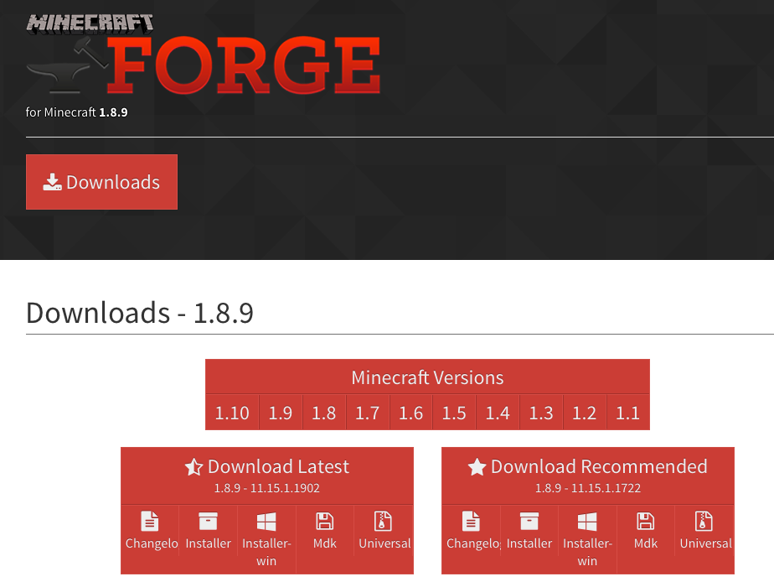

Select download i**nstaller** first the **Mdk** then

Extract zip file

Created a folder tutorial_1.8 and copied extraced files

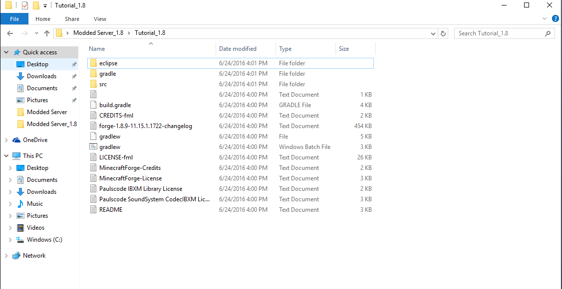

@ DOS Command prompt run

**gradlew setupDecompWorkspace**

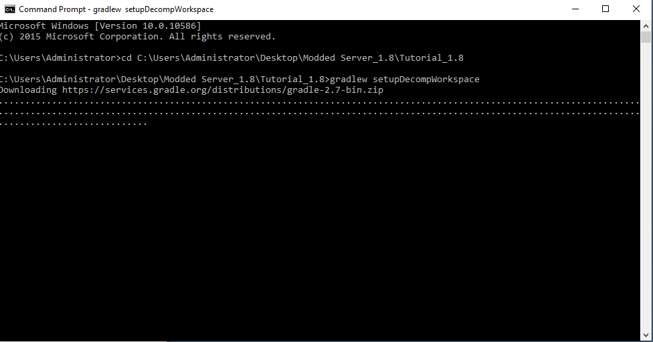

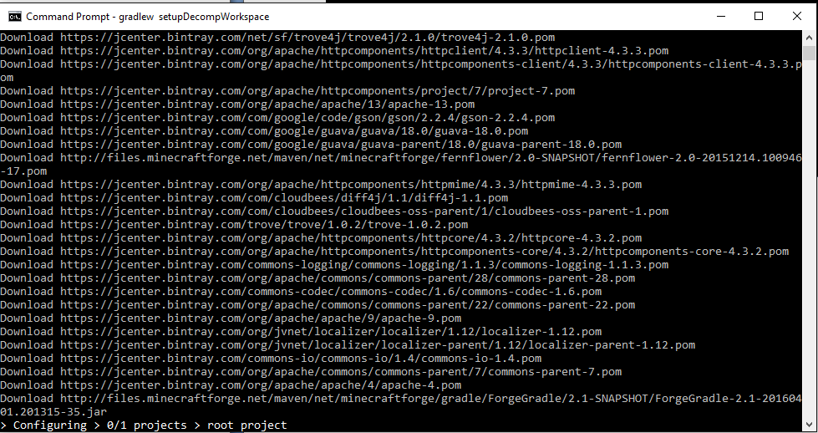

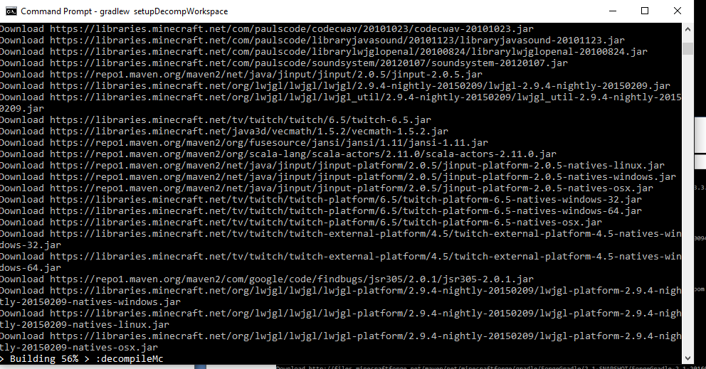

next @ Command prompt run

**gradlew eclipse**

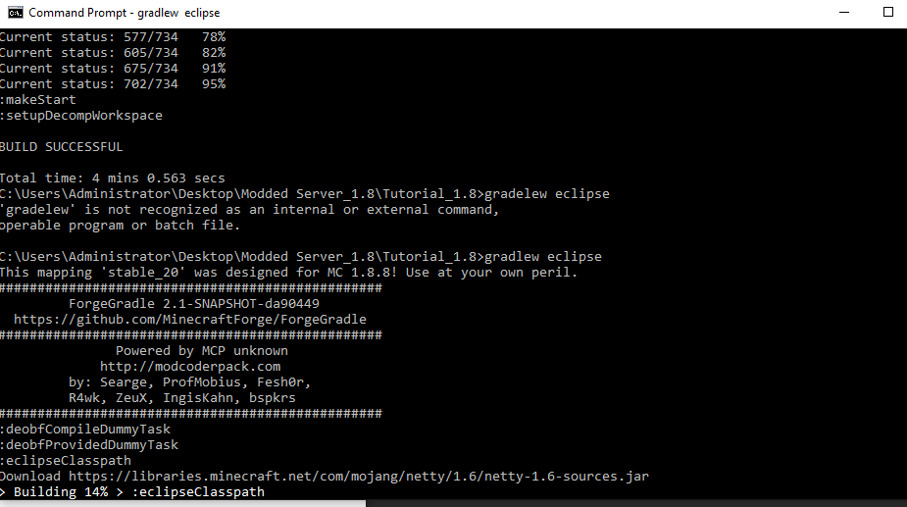

finally @ Command prompt run

**gradlew build**

